
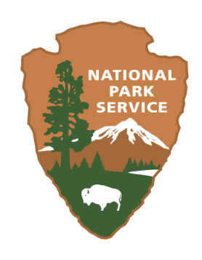
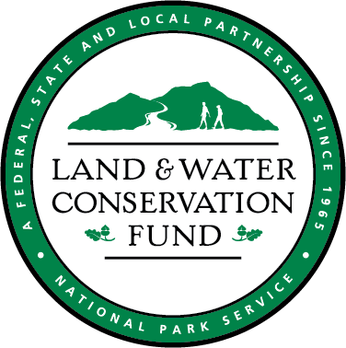
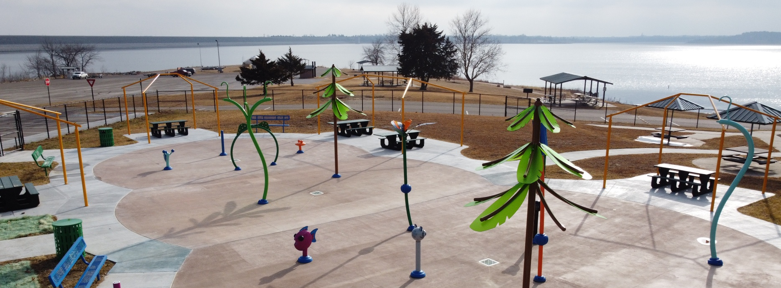
Milford State Park Splashpad
KDWP: State Parks Division
512 SE 25th Ave
Pratt, KS 67124
620 672 5911
Land and Water Conservation Fund: 2026 Project Application

KANSAS
Table of Contents

Section 1……….……..….About the Land and Water Conservation Fund (LWCF)
Section 2………………….Kansas LWCF Program Administration
Section 3……….……..….Application Submission Instructions
Section 4..………………..Application Checklist
Section 5……….….……..Application Summary
Section 6………………….Project Narrative
Section 7………………….Financial Profile
Section 8……….…………Property Information and Maps
Section 9.…………………Community Engagement Summary
Section 10………….…….Environmental and Historic Preservation
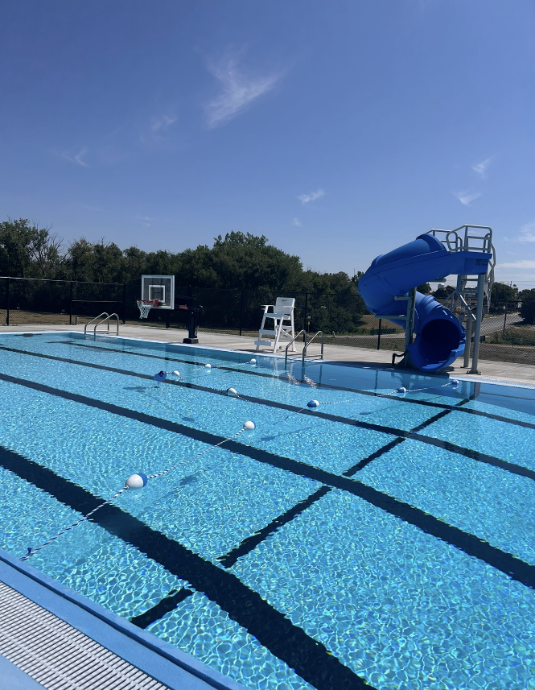
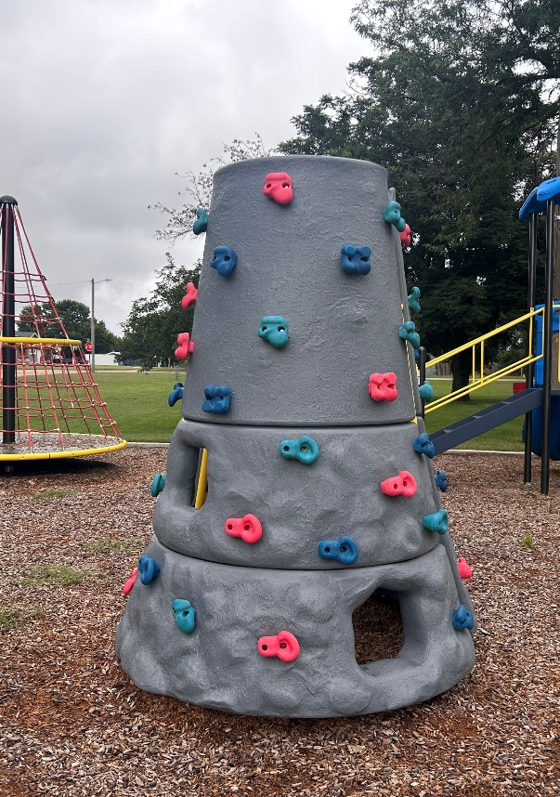
Section 11……..…………Reference Materials

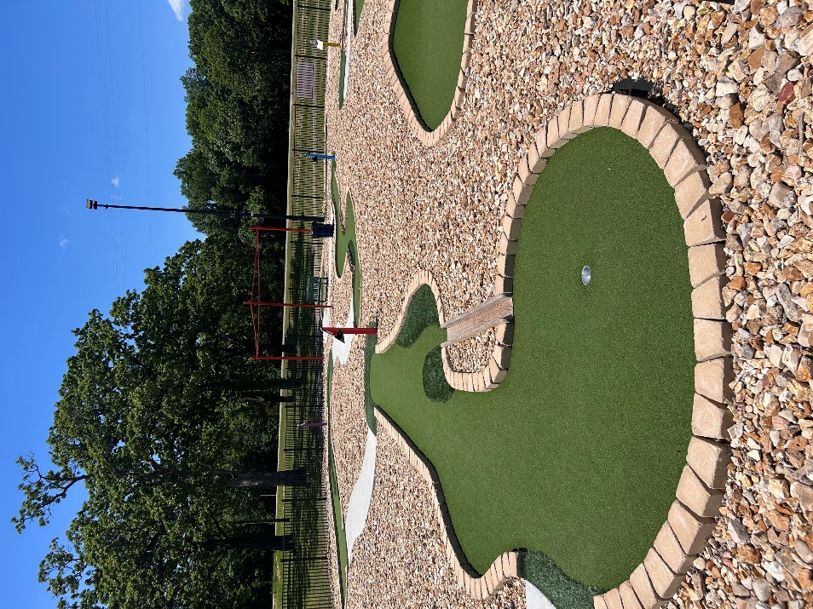

Spence Park – Lewis, KS
Ness City Pool – Ness City, KS
Four Oaks Golf Course – Pittsburg, KS
About the Land and Water Conservation Fund (LWCF)
Conservation and Recreation
The Land and Water Conservation Fund (LWCF) is a landmark federal program established by Congress in 1964 to preserve and enhance outdoor recreation opportunities across the United States. Through LWCF, billions of dollars have been invested nationwide to protect natural areas, develop public outdoor recreation facilities, and ensure that all Americans have access to parks, trails, and open spaces.

Funding Source
The LWCF is funded primarily through revenues from offshore oil and gas leasing—not taxpayer dollars. These funds are reinvested in conservation and recreation projects in every state and nearly every county across the nation. Funds are also invested in five U.S. territories, including Puerto Rico, Guam, the U.S. Virgin Islands, American Samoa, and the Commonwealth of the Northern Mariana Islands.

Administration in Kansas
In Kansas, the program is administered by the Kansas Department of Wildlife and Parks (KDWP). LWCF provides matching grants to state and local governments for the acquisition and development of public outdoor recreation areas and facilities. Projects often include the creation or improvement of playgrounds, restrooms, sports courts, trails, and park amenities that enhance community outdoor recreation opportunities.

National Commitment
The Great American Outdoors Act (GAOA), passed in 2020, permanently funds LWCF at $900 million annually, ensuring a reliable and long-term investment in America’s public lands, local parks, and outdoor recreation resources.
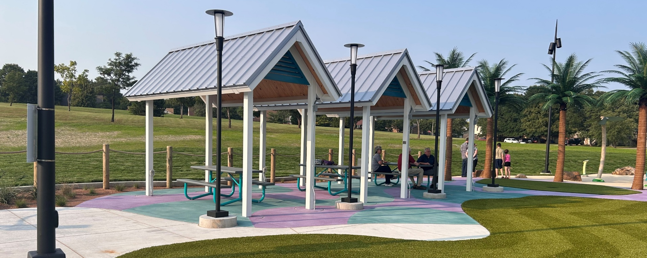
Derby Public Library – Derby, KS
Kansas LWCF Program Administration
In Kansas, the Land and Water Conservation Fund (LWCF) is administered by the Kansas Department of Wildlife and Parks (KDWP) within the State Parks Division. KDWP manages the program in partnership with the National Park Service (NPS), ensuring that all projects align with federal LWCF requirements and state outdoor recreation priorities.
Eligible Project Types
There are three types of eligible LWCF projects: Acquisition, Development, and Combination.
- Acquisition projects involve the purchase of land or water areas for permanent public outdoor recreation use, such as acquiring property for a new park, trail corridor, or natural area.
- Development projects include the construction or renovation of outdoor recreation facilities—examples include playgrounds, sports courts, restrooms, picnic shelters, trails, and other park improvements.
- Combination projects include both land acquisition and facility development components within a single application, such as purchasing land for a new park and developing recreation amenities on the same site.
Renovation projects can be eligible. Funding may be used to bring existing facilities up to current codes, such as ADA accessibility or public health and safety standards.
All projects must provide permanent public outdoor recreation benefits and comply with LWCF requirements regarding public access, use, and protection under Section 6(f)(3) of the LWCF Act.
Application and Funding Overview
Local government entities, including cities, counties, public schools, Native American tribes and recreation departments are eligible to apply for LWCF assistance.
- Application Limit: Each eligible sponsor may submit one project application per year.
- Match Requirement: LWCF is a 50% reimbursement program, meaning the sponsor is responsible for all initial project expenses and is reimbursed for up to 50% of total eligible project costs after proof of payment is submitted. If other federal funding is proposed as match, it must be clearly identified in the application and sponsors should consult with KDWP in advance to confirm eligibility.
- Funding Range: There is no minimum or maximum cap on federal funding requests. KDWP has awarded projects ranging from $10,000 to over $1 million, depending on scope, eligibility, and available funding.
Application Schedule
KDWP typically accepts LWCF project applications once per year. For the 2026 grant cycle, completed applications must be submitted by July 31, 2026.
All applications should be emailed to: Riston Landwehr, LWCF Coordinator | riston.landwehr@ks.gov
Project Selection and Review Process
Before submitting an application, sponsors should carefully review the following documents:
(Both documents can be found within the reference materials in Section 11)
- The Kansas LWCF Open Project Selection Process (OPSP) – outlines how projects are scored, ranked, and selected for funding.
- The Kansas Statewide Comprehensive Outdoor Recreation Plan (SCORP) - identifies Kansas’ recreation needs, goals, and priorities. (The 2021-2025 SCORP document is the most current version. The 2027-2037 study will be completed prior to the 2027 application deadline.)
Following submission, eligible projects undergo a series of reviews, which may include:
- KDWP site inspection and eligibility verification
- Kansas LWCF Review Board Ranking and Recommendation
- NEPA (National Environmental Policy Act) and NHPA (National Historic Preservation Act) compliance reviews
- Final approval by the National Park Service (NPS)
The typical timeline from application submission to award is approximately 3–6 months, although some projects may take longer depending on review complexity and funding year.
Important Compliance Notes
No ground-disturbing activities, land acquisitions or project expenditures may occur before federal approval and the execution of a local agreement, unless a Waiver of Retroactivity has been granted by the NPS. Initiating work or transferring a title of land before these steps may render a project ineligible for reimbursement.
All LWCF-assisted properties are protected in perpetuity under Section 6(f)(3) of the Land and Water Conservation Fund Act and are subject to regular inspection. This means that any park or site developed or acquired with LWCF funds must remain dedicated to public outdoor recreation use forever, unless a formal conversion of use is approved by the Kansas Department of Wildlife and Parks (KDWP) and the National Park Service (NPS).

Application Submission Instructions
Application Deadline and Submission
All 2026 Kansas LWCF project applications must be submitted by July 31, 2026.
Completed applications must be emailed to:
Riston Landwehr, LWCF Coordinator | riston.landwehr@ks.gov
Late or incomplete applications will not be accepted.
Application Requirements
Answer all questions in full. Do not respond to any question with “see attached.” Information should be entered directly into the application form where indicated.
Typed submissions only. Handwritten forms or applications will not be accepted.
Do not alter application formatting. Please complete all fields within the existing form layout. Changes to font size, structure, or spacing may cause compatibility issues during review.
Provide clear and concise responses. Ensure that descriptions are detailed enough to communicate project intent, eligibility, and alignment with program goals.
Supporting Documentation
Applicants are encouraged to include relevant supporting materials at the end of the application. These may include:
- Letters of Support from community leaders, organizations, or stakeholders
- Park or Recreation Master Plans
- Feasibility Studies, Design Concepts, or Campaign Materials
- Other Relevant Documents that strengthen the project’s justification or demonstrate community need
All attachments should be clearly labeled and submitted in digital format (PDF preferred).
Additional Tips
- Review the Kansas LWCF Open Project Selection Process (OPSP) to understand how projects are evaluated and scored.
- Review the Kansas Statewide Comprehensive Outdoor Recreation Plan (SCORP) to ensure your project aligns with Kansas’ recreation goals and priorities.
- Double-check that all sections of the application are complete, signatures are included where required, and attachments are properly referenced at the end.
- Review Example Documents that are provided to ensure documents such as the Project Budget and Property Maps align with application requests.
Questions
All questions regarding the Kansas LWCF program or application should be directed to the program coordinator. Riston Landwehr | riston.landwehr@ks.gov | 620 672 5911

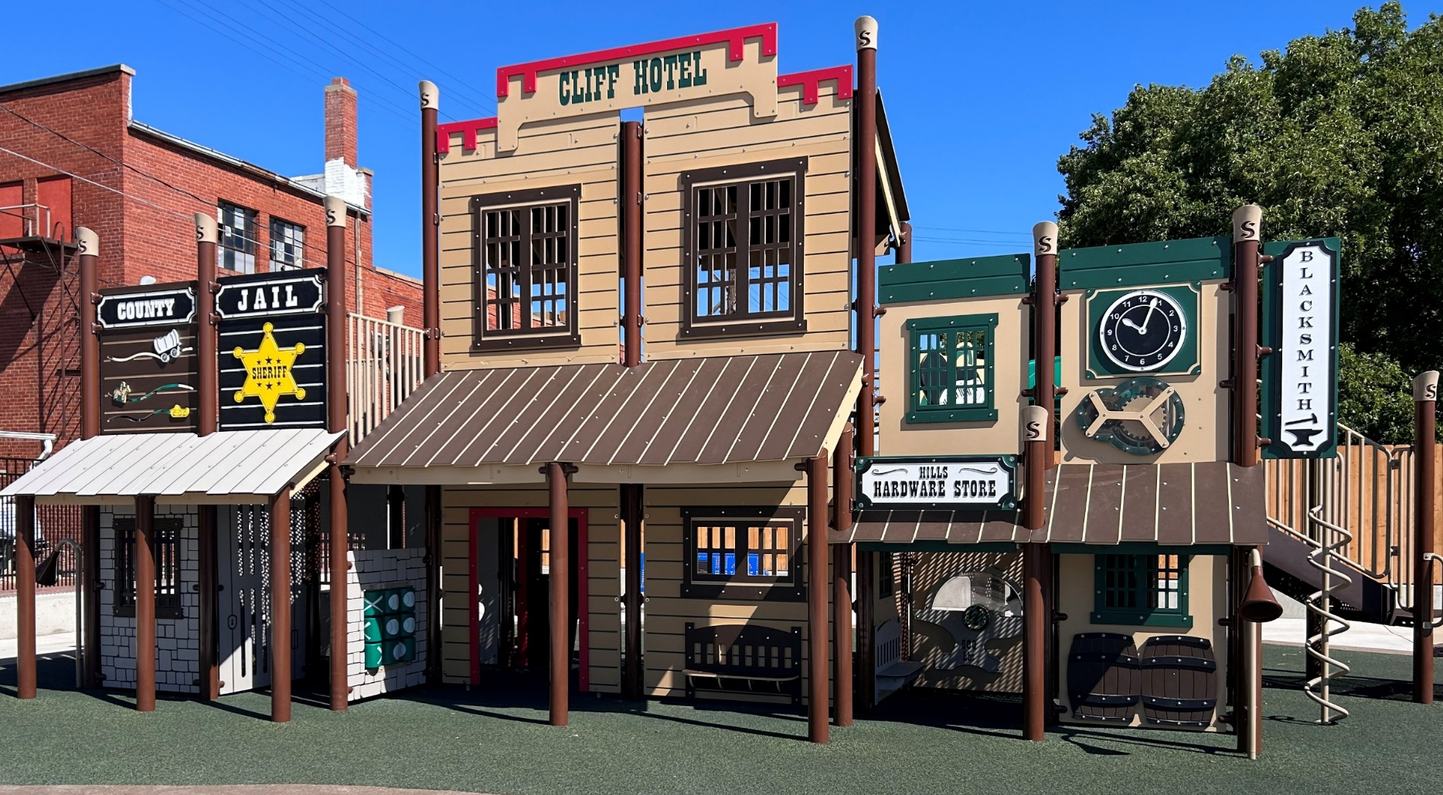
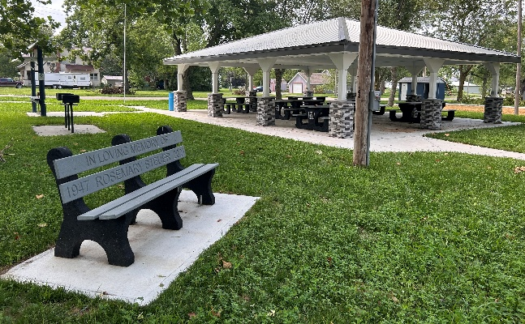
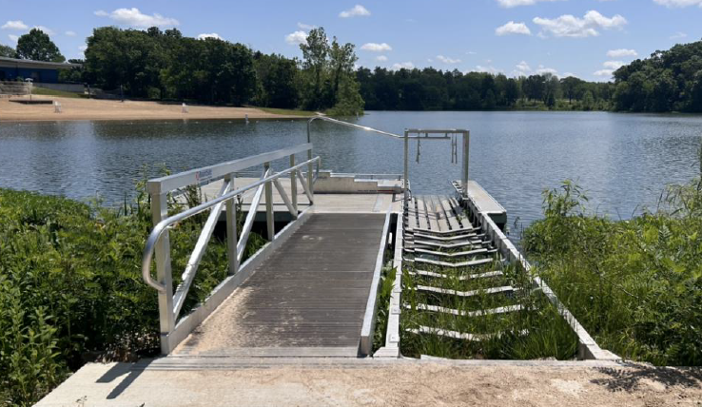
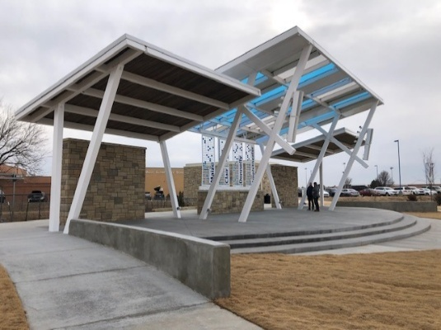
Application Checklist
Russell Historic Park – Russel, KS
Shawnee Mission Park – Johnson County, KS
Maize City Park – Maize, KS
Summerfield Community Park – Summerfield, KS
The following documents are required as part of your application. Incomplete applications will not be considered for funding.
  - Application Summary
  - Project Narrative
  - Project Budget
  - Local Funding Source Statement
  - Proof of Ownership or Management
  - Applicable Maps
  - Community Engagement Summary
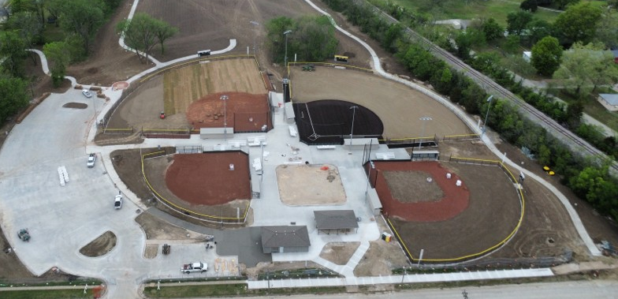
  - Environmental and Historic Preservation Information
Central Park Sports Complex – Independence, KS
Application Summary

Project Sponsor Information
Project Sponsor: Click or tap here to enter text.
Primary Contact Name: Click or tap here to enter text.
Primary Contact Title: Click or tap here to enter text.
Mailing Address: Click or tap here to enter text.
Phone Number: Click or tap here to enter text.
Email Address: Click or tap here to enter text.

Project Site Information
Project Title: Click or tap here to enter text.
Type of Project:
(Acquisition, Development, Combination) Click or tap here to enter text.
Park Name: Click or tap here to enter text.
Park Address: Click or tap here to enter text.
Full Park Acres: Click or tap here to enter text.
Previous LWCF Funding at Site:
(List Grant Numbers, 20-00### or N/A) Click or tap here to enter text.

Brief Project Description
(Ex: The City of Pittsburg will complete phase II developments of the Lincoln Park Pavillion. Scope elements include sidewalk connections, lighting, benches and waste receptacles.)
Click or tap here to enter text.

Project Cost
Total Project Cost Click or tap here to enter text.
Federal Funding Request Click or tap here to enter text.
Local Match Funding Click or tap here to enter text.

Certification
I hereby certify that the information contained in this application and all supporting documents are, to the best of my knowledge, both true and accurate. The submission of this application has been duly authorized by the governing body of the applicant (project sponsor), and the applicant/project sponsor will comply with the attached assurances if assistance is awarded.
Authorized Representative (Name and Title):

Project Narrative
Respond to the following questions to help us understand the purpose, scope, and impact of the proposed LWCF project. Responses should provide clear, concise descriptions of the project’s need, design, public input, and long-term value to your community. Limit each response to 300 words.

Project Justification
- What community challenges or recreational gaps will this project help address?
Consider who in your community will benefit most, and how the project improves access or experiences for users.
Click or tap here to enter text.

- In what ways does this project reflect broader outdoor recreation goals or planning efforts at the local, regional, or state level?
You may reference relevant plans (SCORP), strategies, or statewide priorities that guided the project’s development. If attaching park master plan, please reference relevant page numbers.
Click or tap here to enter text.

- What steps have been taken to prepare for this project?
Briefly describe any planning, design, or preliminary work already completed, and how it supports the overall readiness of the project.
Click or tap here to enter text.

- How did community members or stakeholders help shape this project?
Please share any input received through surveys, meetings, or public comment—and how that input influenced project decisions.
Click or tap here to enter text.

- How will the project be welcoming and usable for people of all ages, abilities, and backgrounds?
Include features or design considerations that promote inclusive and accessible recreation.
Click or tap here to enter text.

- How does the proposed budget reflect the value and impact this project will provide?
You can touch on how the cost supports the scope of work, anticipated outcomes, or long-term benefits.
Click or tap here to enter text.

- What types of outdoor recreation will this project support, and how does it fit within your overall park or facility system?
Help us understand how the proposed improvements expand or complement what already exists. What does your current park and recreation inventory look like/what is the state of existing facilities?
Click or tap here to enter text.

- How will your agency manage the project and ensure long-term care of the site?
Consider organizational capacity, experience with similar projects, and your approach to future upkeep and stewardship.
Click or tap here to enter text.

Project Description
- What work will this project include?
Describe the full scope of improvements or development planned using LWCF funding. List all specific components or features to be completed.
Click or tap here to enter text.

- How will this project help meet the need(s) identified in your narrative?
Explain how the work you plan to do directly addresses the challenges or gaps you described earlier.
Click or tap here to enter text.

- Who will this project serve, and how does it meet local recreation needs?
Identify the main user groups (age, ability, interest, etc.) and explain how the project improves or expands recreational access for them.
Click or tap here to enter text.

- When and how will the public be able to use the new facility or space?
Provide expected months of operation, days/hours of public access, and any seasonal limitations. Are there any times where the facility will be closed for exclusive use (school sports practice, etc.)
Click or tap here to enter text.

- Who will complete the work, and what is your timeline?
Describe whether work will be completed by contractors, staff, or volunteers. Include major project milestones with an estimated schedule.
Click or tap here to enter text.

- If similar public or private facilities already exist nearby, why is this one needed?
Explain why this project is justified even if similar spaces are available elsewhere in your community.
Click or tap here to enter text.

- Is there anything else you'd like us to know about your project?
Provide any additional information that helps explain the importance or impact of the work you’re proposing.
Click or tap here to enter text.

(Questions 16 and 17 are for Acquisition or Combination Projects ONLY)
- How will the land be acquired, and how many acres are involved?
Describe the property and explain the acquisition method (purchase, donation, etc.).
Click or tap here to enter text.

- What is currently on the property, and what will it be used for after acquisition?
Describe existing resources or improvements, and what will happen to them. Include any interim use or relocation plans.
Click or tap here to enter text.

Financial Profile
Project Budget
- A project budget is required and must be submitted in Excel format. An example project budget is provided within Section 11 of this application for reference.
- Costs must be broken down into clear categories (Administration, Engineering, Construction, etc.) with detailed expense line items under each. Lump sum totals will not be accepted without itemization.
- All proposed expenses must be compliant with Build America, Buy America (BABA) requirements, as outlined by the U.S. Department of the Interior. Applicants are responsible for ensuring all line items meet applicable sourcing and material standards. (“Build America, Buy America”)
- Contingency costs may be included but must be accompanied by a brief justification explaining how the amount was calculated and why it is appropriate for the project scope.
- Overall Budget should be rounded to the nearest $100.
  - (Ex: $125,875.56 $125,900.00)

Local Funding Source Statement
- A local funding statement must be submitted with this application. In the Reference Materials, you will find the form to be completed. The statement must identify the sponsor’s source of matching funds, the amount to be contributed, and the expected date of availability. It must be certified by the Mayor, Commission Chair, or Board President, as applicable. Please insert sponsor letterhead to form.

Property Information and Maps

Land Ownership
- Sponsor control of the project site is required prior to project approval. Therefore, a Certified Title Opinion must be submitted with the application. This document should include a legal description of the property and clearly identify any rights or interests, including adverse claims held by others.
- A copy of the recorded deed showing the sponsor’s ownership of the property must also be submitted as a supporting document to the Title Opinion.
- In lieu of a Title Opinion and deed, applicants may submit a lease agreement—existing or proposed—with a minimum term of 25 years. A copy of the lease must be included with the application.
- For acquisition projects, a completed Willingness to Sell Form is required. This form is available in the Reference Materials in Section 11.

Maps
A few different maps will be required to be attached to your application. Please read carefully below and review the example maps in Section 11 to ensure maps are submitted correctly.

State Map
- Attach a map of the State of Kansas identifying the location of the city where the project will reside.

Location Map
- Provide an aerial map of the city or county clearly identifying the location of the project site or park. The map should be labeled and provide enough context to show its position relative to major roads, landmarks, or city boundaries.

Area of Potential Effect (APE) Map
- Provide a map that highlights the boundary of the park and shows the surrounding vicinity where the proposed development will occur. The APE map should clearly depict the full area that may be impacted—directly or indirectly—by the project.

Site Plans
- Submit a detailed site plan that illustrates the proposed improvements within the park or project area. The plan should clearly show the layout, dimensions, and location of all existing and planned features, such as trails, playgrounds, restrooms, parking, signage, or utilities.

Right-of-Ways and Easements
- If ROWs or Easements exist within the park boundary, please include a map to identify areas.

Floor Plans
- If your project includes buildings or enclosed structures (e.g., restrooms, shelters, visitor centers), please submit floor plans showing the internal layout of each facility.

Community Engagement Summary

Community input, support, and involvement are essential components of a successful project and are strongly considered during application scoring. With a 500-word maximum, please explain community involvement in the planning of the proposed project. Please address the following, as applicable:
- Describe any public meetings, forums, or surveys that informed project decisions.
- Identify how stakeholder feedback helped shape the project scope, design, or priorities.
- List any local partnerships, sponsorships, donations, or in-kind contributions that have supported the planning, funding, or promotion of the project.

Please attach the following items as applicable:
- Public hearing minutes or meeting summaries where the project was discussed
- Public surveys or polls defining local needs and wants
- Letters of support from individuals, local leaders, or organizations
- Documentation of donations, sponsorships, or partnership agreements

Community Engagement Summary
Click or tap here to enter text.

Environmental and Historic Preservation
With LWCF being federally funded, all projects must comply with federal and state review requirements before construction begins. This includes evaluating potential impacts to cultural and historic resources, as well as assessing environmental effects on land, water, vegetation, and wildlife. The information provided in this section will be used to complete the Kansas State Historic Preservation Office (SHPO) project review and necessary environmental reviews. (Please explain each answer in full)

- Describe all necessary construction, excavation, grading, or filling activities related to this project.
Click or tap here to enter text.
- Will the project involve removing trees or vegetation, or alteration of the existing landscape?
Click or tap here to enter text.
- What is the maximum expected depth of ground disturbance?
  - ☐ 0-6 Inches
  - ☐ 6-18 Inches
  - ☐ 18-36 Inches
  - ☐ Greater than 36 Inches
- What is the current condition and use of the site? Has there been prior ground disturbance?
Click or tap here to enter text.
- Does the project site contain or is it located near any known historic features, cemeteries, structures over 50 years old, or within a designated historic district?
Click or tap here to enter text.
- Is the project located near or within any wetlands, floodplains, streams or bodies of water?
Click or tap here to enter text.
- Will the project have any impact on existing wildlife or their habitats?
Click or tap here to enter text.
- Will this project require any local, state, or federal permits or consultations for approval or completion?
Click or tap here to enter text.

(Please include current photos of the project site for reference.)

